CAM Module Installation Firmware
The QD002 expansion pack is based on the QD001 smart car, so if you purchased the car and expansion pack, please use the QD001 tutorial to learn the basics first.

Next, you'll see how the CAM module installs firmware.

1.Connect the ESP32 CAM module controller board to the PC using a USB cable.

2.Open the Thonny programming software.
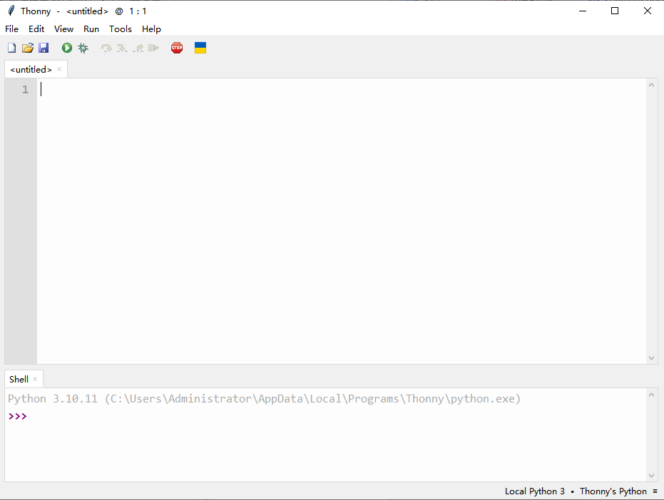
2.Click on the bottom right corner and click Configure interpreter.
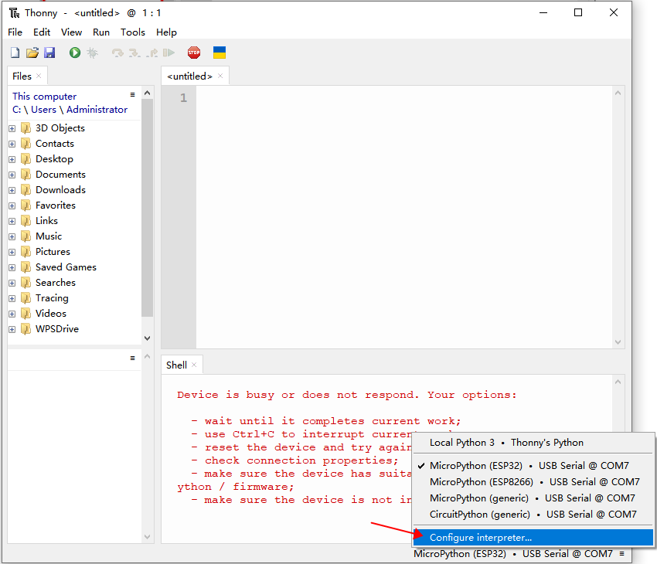
3.Click “Install or update MicroPython”
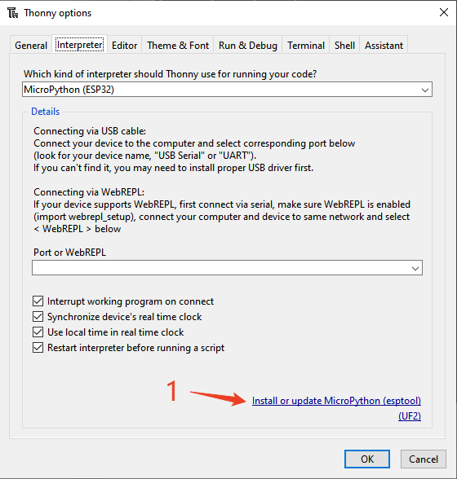
4.Click the icon to select “Select local MicroPython image...”
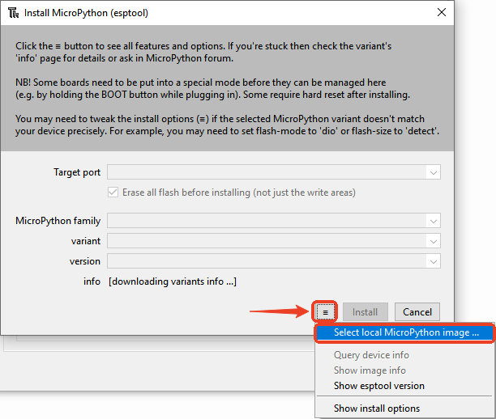
5.Click "ESP32CAM_firmware.bin" file in python/English/ACEBOTT QD005 ESP32 Shooting Car B/3.Firmware.
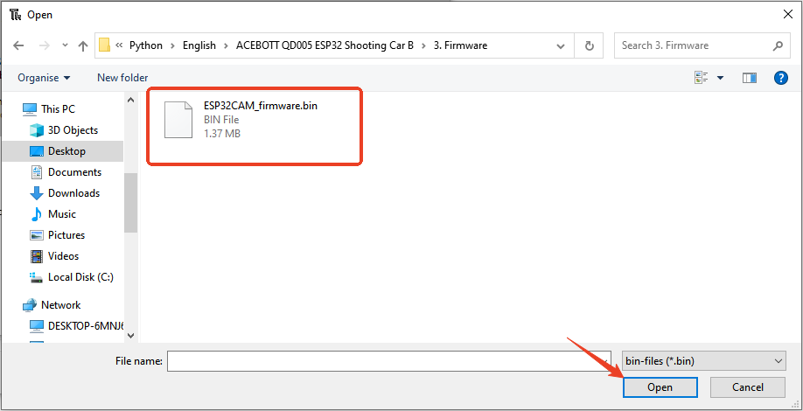

6.Click Select serial port, then click “Install”
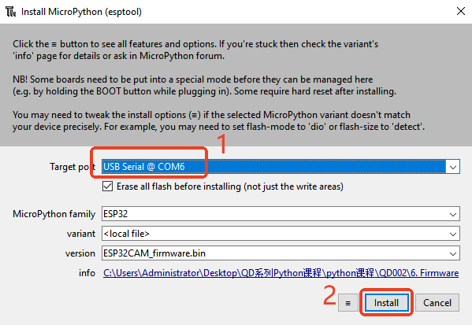

7.Waiting to download firmware. When the download is complete, click “Close”。
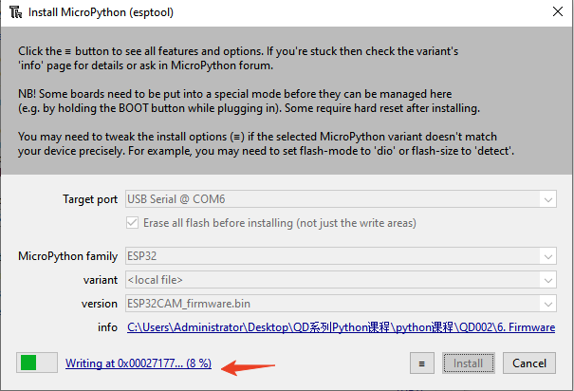

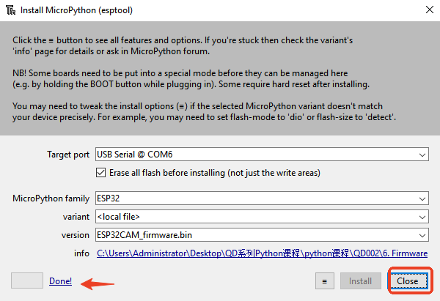

8.Finally click“OK”
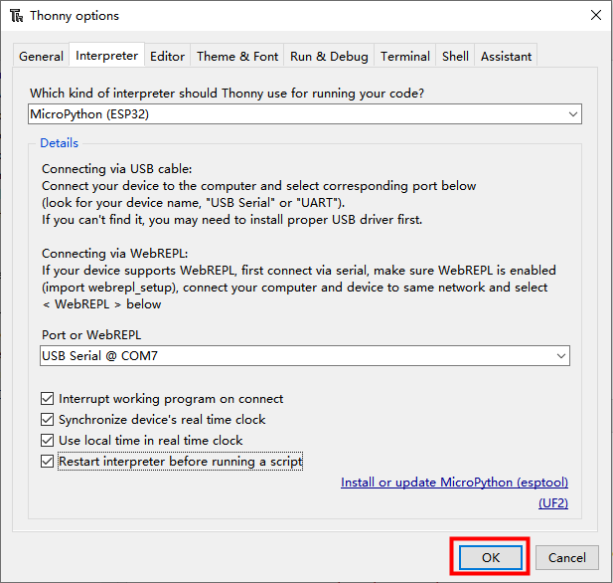
9.After downloading the firmware successfully, the CAM module will appear in the file bar “boot.py”。
